Assignments on String Class

1)Write an application to determine the length of the String str = Hello World”. (Hint: Use String Method)

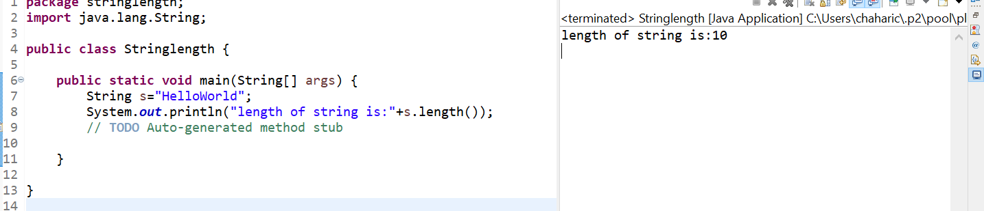

2)Write an application to join the two strings “Hello,” & “How are you”.

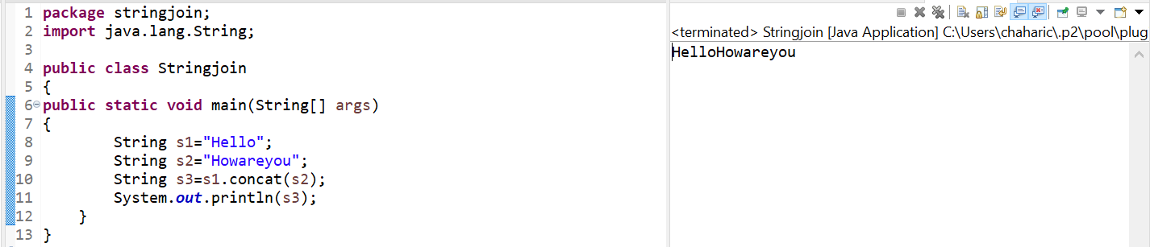

3)Given a String “java string pool refers to collection of strings which are sorted in heap memory”, perform the following operations.

a) Print the string to console in lowercase.

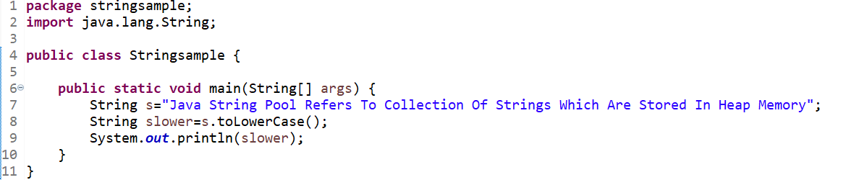

Output:



b) Print the String to console in Uppercase.

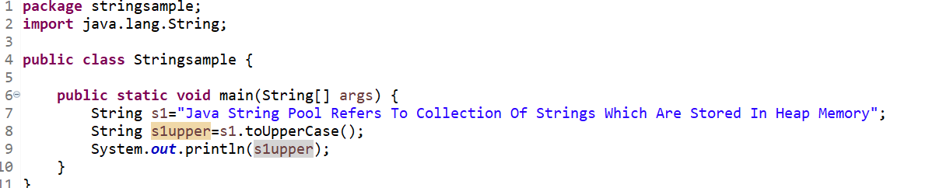

Output:



c)Replace all ‘a’ character in the string with $ sign.

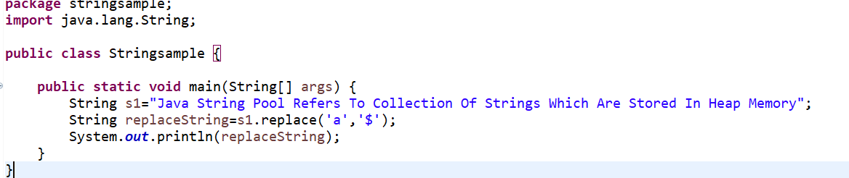

Output:



d)Check if the original string contains the word “collection”.

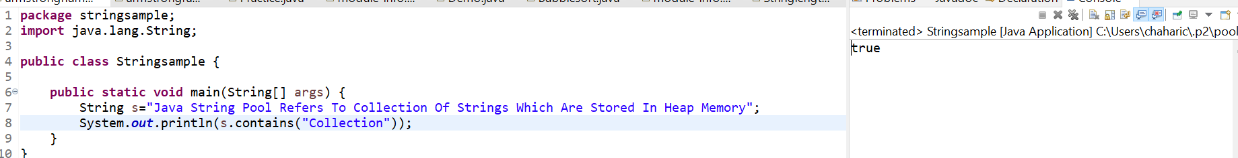

E) Check if the following string “java String pool refers to collection of strings which are stored in heap memory” matches the original.

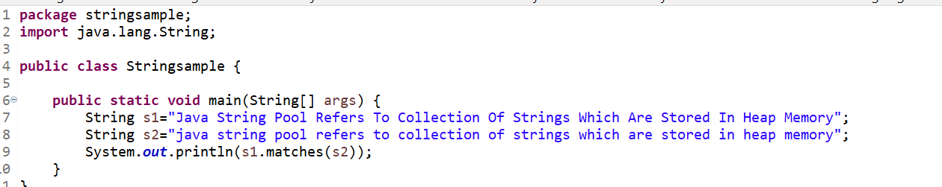

Output:



Assignments on String Buffer Class

1)Write an application to append the following strings “String Buffer ” , “is a peer class of string”, ”that provides much of “,”the functionality of strings” using a string buffer.

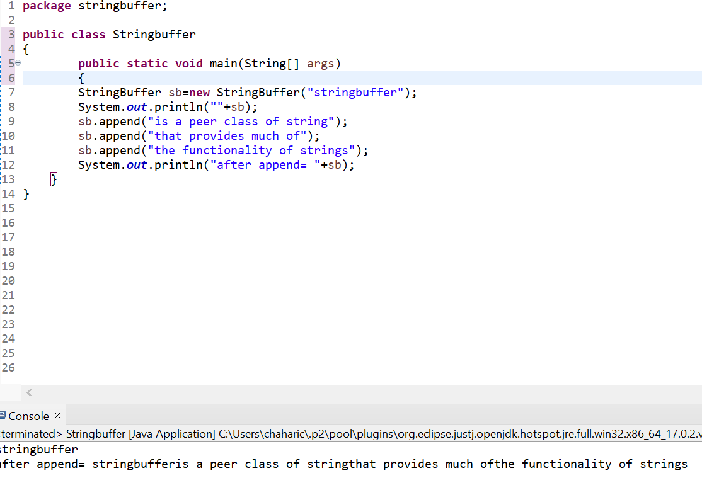

2)Reverse the following string “This method returns the reversed object on which it was called “using String buffer class”.

